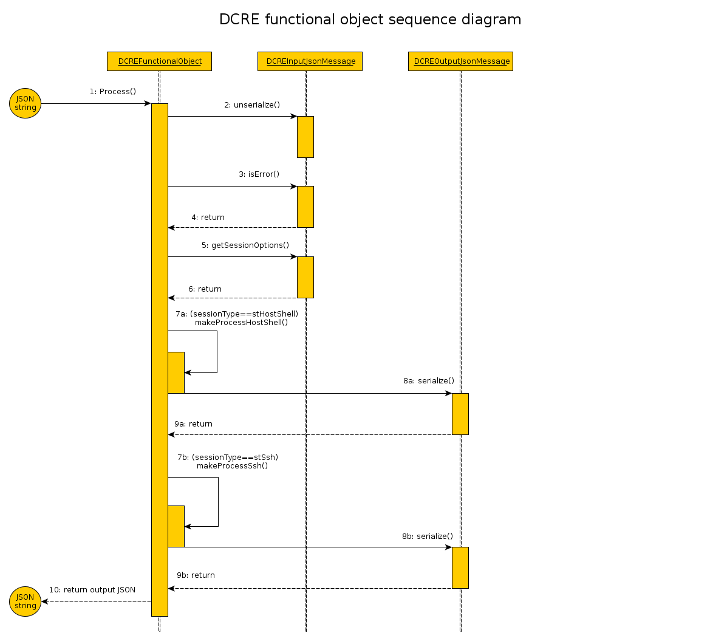
1) Input JSON string is passed as a parameter to call method Process of class DCREFunctionalObject.
Next work take place in “Black Box”.

2) Call unserialize() - exctract data out input JSON string in object class type DRCEInputJsonMessage
.
3) For check result state after last operation call method isError() for class DRCEInputJsonMessage.

4) Return of result. Must be false (no errors), otherwise next step of executing doesn't have sense.

5) Call method getSessionOptions() of class DRCEInputJsonMessage for extract structure SessionOptions need to initialization
6) Return structure SessionOptions.

7a) If sessionType equals stHostShell call method makeProcessHostShell().
7b) If sessionType equals stSsh cal method makeProcessSsh().
8a) and 8b) Return value to DCREOutputJsonMessage and call method serialize().

9a) and 9b) Return serialized data to DCREFunctionalObject.

10) Return output “Black Box” of JSON message.

