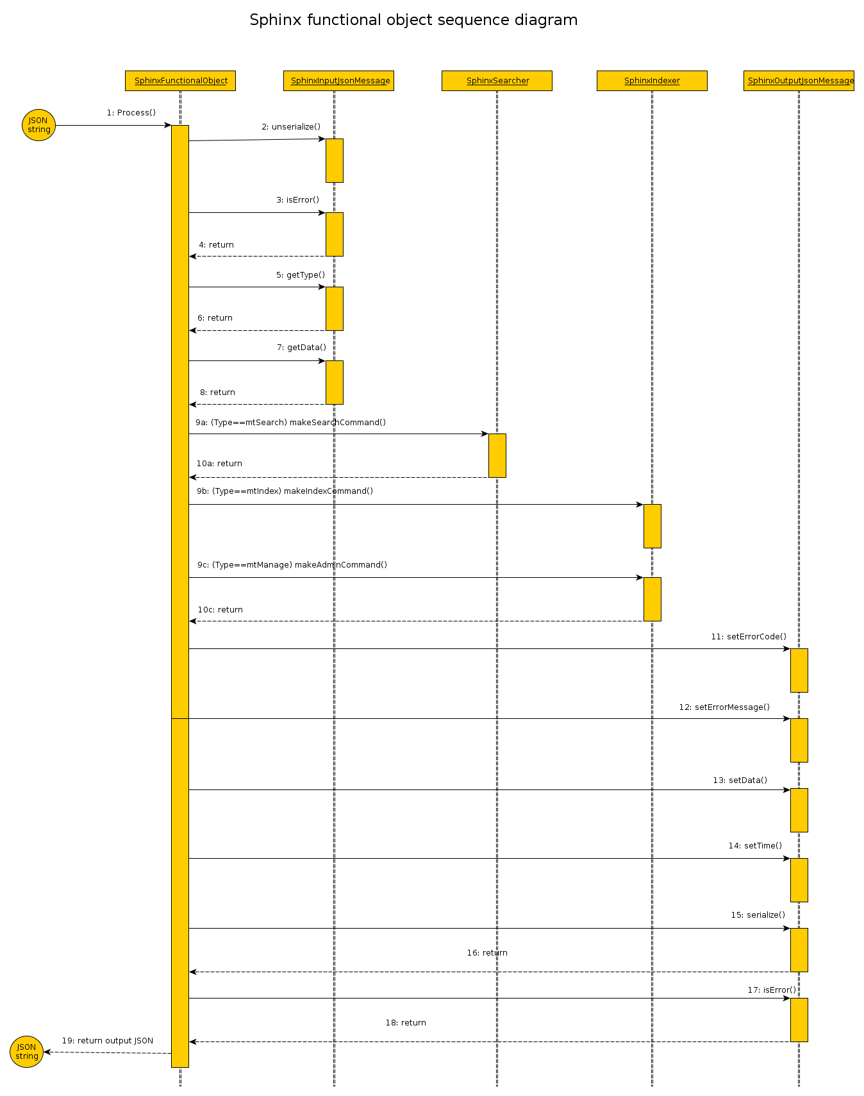

1) Input JSON string is passed as a parameter to call method Process of class SphinxFunctionalObject.
Next work take place in “Black Box”.

2) Call unserialize() - exctract data out input JSON string in object type SphinxInputJsonMessage.

3) For check result state after last operation call method isError() for class SphinxInputJsonMessage.

4) Return of result. Must be false (no errors), otherwise next step of executing doesn't have sense.

5) Call method getType() of class SphinxInputJsonMessage for extract type of message according to protocols.
6) Return type (Search, Index or Manage).

7)Call getData() of class SphinxInputJsonMessage for extract JSON data string.
8) Return JSON data string.

Next step depend of got type messages:
9a) If type equal Search then call method makeSearchdCommand() of class SphinxSearcher.
10a) Return result of search.
9b) If type equal Index then call method makeIdexCommand() of class SphinxIndexer.
9c) If type equal Manage then call method makeAdminCommand() of class SphinxIndexer.
10c) Return result of execute manage command.

Next list of calls methods class SphinxOutputJsonMessage forms output message:
11) Call setErrorCode() - set error code of result executed commands
12) Call setErrorMessage() - set error message of result executed commands
13) Call setData() - set result data need append to output JSON format.
14) Call setTime() - set full time processing in “Black Box”.
15) Call serialize() - build result JSON string
16) Return result output JSON string.

17) Check validate operation of build JSON string by means of call isError().
18) Return result check.

19) Return output JSON message as result of work all steps “Black Box”.

