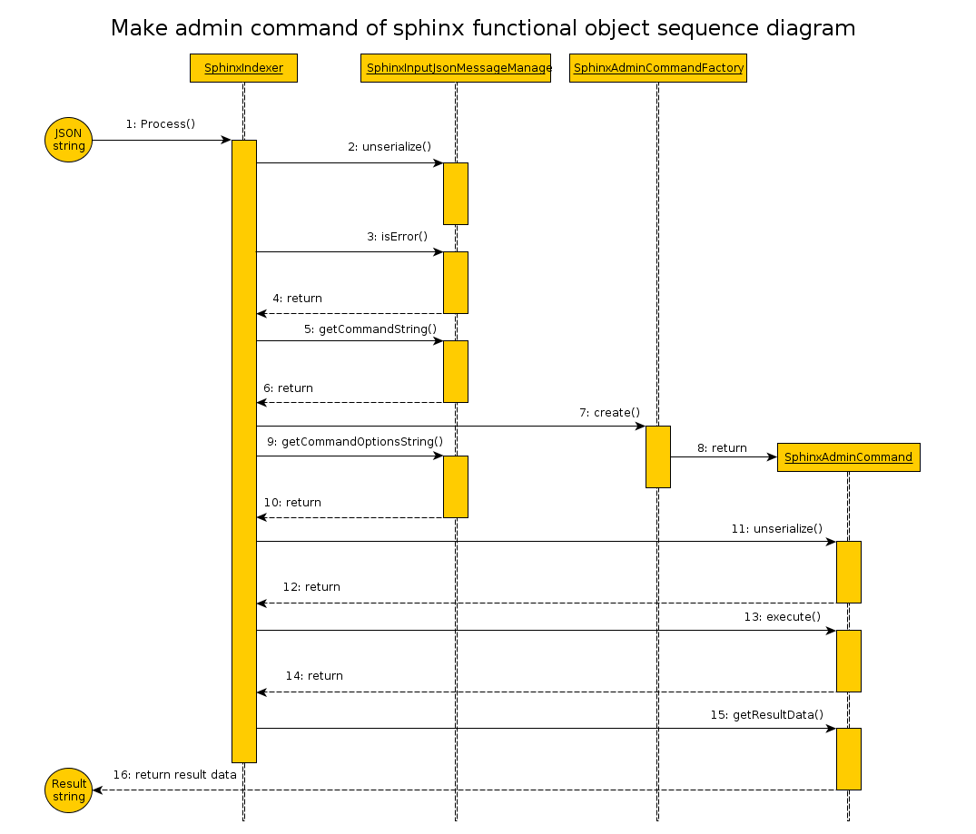
1) Input JSON string is passed as a parameter to call method Process of class SphinxIndexer.
Next work take place in “Black Box”.

2) Call unserialize() - exctract data out input JSON string in object type SphinxInputJsonMessage.

3) For check result state after last operation call method isError() for class SphinxInputJsonMessage.

4) Return of result. Must be false (no errors), otherwise next step of executing doesn't have sense.

5) Call getCommandString() for class SphinxInputJsonMessage

6) Return type of manage command

7) Call method create() of class SphinxAdminCommandFactory receiving as parameter type of manage command

8) Return created class derived from SphinxAdminCommand
9) Call getCommandOptionsString() for class SphinxInputJsonMessage.

10) Return received JSON string.

11) Call method unserialize() for class derived from SphinxAdminCommand use as parameters receiver early JSON string.

12) Return boolean flag about successfully executed last operation.

13) Call method execute() for admin command.

14) Return boolean flag state of executed of command (true -f success, false – otherwise)

15) Call getResultData() for admin command - request for make output data.

16) Return result data as result execute admin command of SphinxIndex in “Black Box”.

