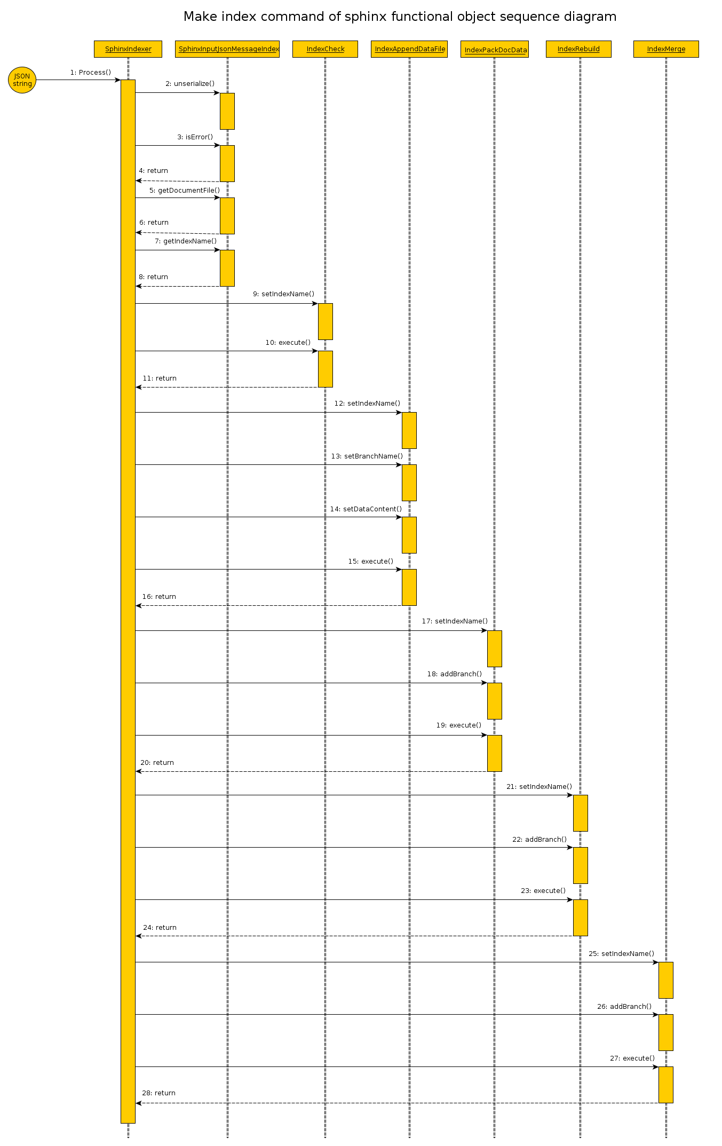
1) Input JSON string is passed as a parameter to call method Process of class SphinxIndexer.
Next work take place in “Black Box”.

2) Call unserialize() - exctract data out input JSON string in object class type SphinxInputJsonMessageIndex.

3) For check result state after last operation call method isError() for class SphinxInputJsonMessageIndex.

4) Return of result. Must be false (no errors), otherwise next step of executing doesn't have sense.

5) Call getDocumentFile() of class SphinxInputJsonMessageIndex for get data content need to apply on indexes.
6) Return data content.

7) Call getIndexName() of class SphinxInputJsonMessageIndex for get index name to functional object.
8) Return index name.

9)Call setIndexName of class IndexCheck for initialization.
10) Call execute() of class IndexCheck for validate structure of index.
11) Return result flag of success operations (true – if success, false – otherwise).

12) Call setIndexName() of class IndexAppendDataFile for initialization.
13) Call setBranchName() of class IndexAppendDataFile for initialization.
14) Call setDataContent() of class IndexAppendDataFile for initialization.
15) Call execute of class IndexAppendDataFile for add received content to data file.
16) Return result flag of success operations (true – if success, false – otherwise).

17) Call setIndexName() of class IndexPackDocData for initialization.
18) Call addBranch() of class IndexPackDocData for initialization.
19) Call execute of class IndexPackDocData for operation delete dublicate and pack data source.
20) Return result flag of success operations (true – if success, false – otherwise)

21) Call setIndexName() of class IndexRebuild for initialization.
22) Call addBranch() of class IndexRebuild for initialization.
23) Call execute of class IndexRebuild for make source files appropriate sphinx xmlpipe schema and rebuild need branches to sphinx index files.
24) Return result flag of success operations (true – if success, false – otherwise)

21) Call setIndexName() of class IndexMerge for initialization.
22) Call addBranch() of class IndexMerge for initialization.
23) Call execute of class IndexMerge for make trunk index files from before then rebuilt branches to sphinx index files.
24) Return result flag of success operations (true – if success, false – otherwise)

